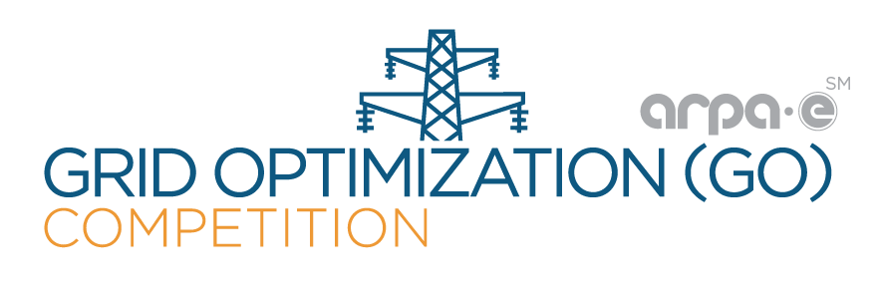
ARPA-E Grid Optimization Competition Workshop
1:15pm-3:30pm June 28, 2018 FERC: 888 First St NE Washington, DC 20426
FERC Conference: Increasing Market and Planning Efficiency and Enhancing Resilience through Improved Software
Abstract: This session will cover the efforts of the Advanced Research Projects Agency-Energy (ARPA-E) in regards to innovative grid software and optimization methods. The Grid Optimization (GO) Competition is one such effort. The GO Competition will have multiple challenges; Challenge 1 will focus on the security-constrained ac optimal power flow (SCOPF) problem. Participants will submit their best algorithmic approach for this non-convex problem and compete to win prize money. This will be an informative session covering the GO Competition: the problem, scoring, rules, prizes, the website, the software platform, submitting your algorithms, and other pertinent information. More information can be found at: https://gocompetition.energy.gov/. Challenge 1 is expected to start in the fall of 2018.
To attend, register for the FERC Conference (see website below). The session will be video recorded and released to the public by ARPA-E soon after the conference.
Speakers:
ARPA-E: Ashley Arigoni, David Guarrera, Kory Hedman
PNNL (GO Competition Administrator and Support Staff): Steve Elbert, Jesse Holzer, Olga Kuchar
Tentative Agenda:
1:15pm-1:35pm Introduction, Timeline, Proposal Track (FOA) and Open Track (ARPA-E/Hedman)
1:35pm-1:45pm GO Competition Platform Overview and Registration (PNNL/Elbert)
1:45pm-1:55pm Input/Output File Format Requirements (PNNL/Holzer)
1:55pm-2:15pm Formulation: Modeling Assumptions (ARPA-E/Hedman)
2:15pm-2:25pm 10 Minute Break
2:25pm-2:40pm Solution Submission/Using the Platform (PNNL/Kuchar)
2:40pm-2:55pm Scoring and Open-Source Evaluation Software (ARPA-E/Guarrera)
2:55pm-3:00pm Eligibility and Rules (ARPA-E/Arigoni)
3:00pm-3:30pm Questions & Answers Session (ARPA-E/Hedman)
FERC’s Conference Website: https://www.ferc.gov/EventCalendar/EventDetails.aspx?ID=10992&CalType=%20&CalendarID=116&Date=06/26/2018&View=Listview. To register: https://www.ferc.gov/whats-new/registration/real-market-6-26-18-form.asp.
For information regarding the GO Competition website and platform, contact the GO Competition Administrator: arpacomp@pnnl.gov. For information on the GO Competition, contact Kory W. Hedman: Kory.Hedman@hq.doe.gov.

